You are expected to solve homework problems individually. If needed, you may seek help from your friends. However, do not copy. Show all steps with your solutions for full credit.

**Name: / 50**

1. Complete the timing diagram below to compare between a Latch and a Flip-flop

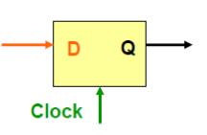

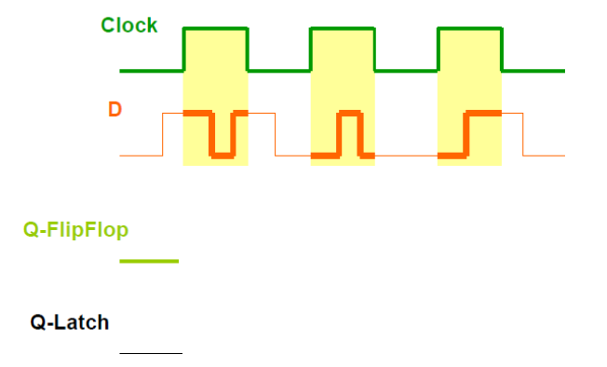

1. Complete the following Excitation tables. Current state (q) and the next expected state (q٭) are given, you are asked to find the input value(s) to D, SR, T, and JK flip-flops. Make any reasonable assumptions.

|  |  |  |
| --- | --- | --- |
| **D flip-flop** | | |
| Q | Qn+1 | D |
| 0 | 0 |  |
| 0 | 1 |  |
| 1 | 0 |  |
| 1 | 1 |  |

|  |  |  |  |
| --- | --- | --- | --- |
| **SR flip-flop** | | | |
| Q | Qn+1 | S | R |
| 0 | 0 |  |  |
| 0 | 1 |  |  |
| 1 | 0 |  |  |
| 1 | 1 |  |  |

|  |  |  |
| --- | --- | --- |
| **T flip-flop** | | |
| Q | Qn+1 | T |
| 0 | 0 |  |
| 0 | 1 |  |
| 1 | 0 |  |
| 1 | 1 |  |

|  |  |  |  |
| --- | --- | --- | --- |
| **JK flip-flop** | | | |
| Q | Qn+1 | J | K |
| 0 | 0 |  |  |
| 0 | 1 |  |  |
| 1 | 0 |  |  |
| 1 | 1 |  |  |

1. For the following edge-triggered D flip-flops show the timing diagram
2. Assume it is a positive-edge- triggered D flip-flop
3. Assuming it is a negative-edge-triggered D flip-flop

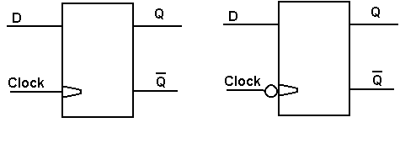

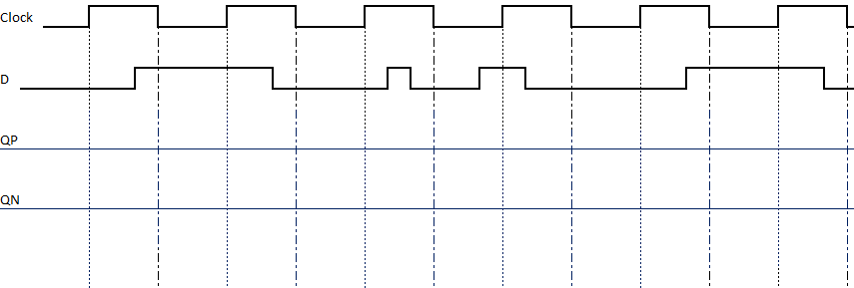

1. Consider the JK flip flop shown below and complete the timing diagram showing Q for as far as you can



